Open application in specific workspace
1.- Install compizconfig-settings-manager
2.- Go to Window Management -> Place Windows -> Fixed Window Placement
3.- Under Windows with fixed viewport click on new:
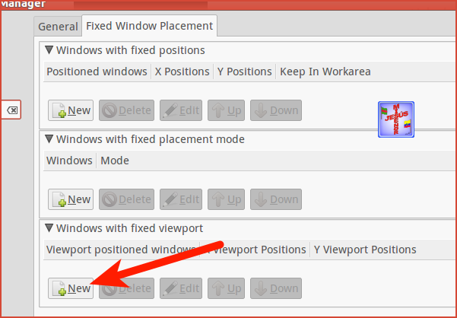
- class=NameOfYourProgram (Here the spelling is important. Better use the green plus sign and "Grab" this parameter in the resulting window)
- Position : {1,1}top left; {1,2}bottom left, ...
- example opens Gnome-terminal in bottom right workspace : 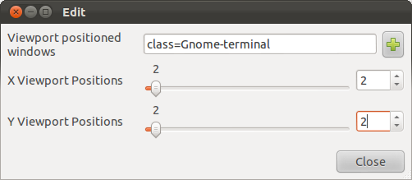
More information on wiki.compiz.org

Yo envio a Skype al espacio de trabajo 2 así:

